Version: V1.0.1



AllGamesCoin (XAGC)

Rebuilding the game world with blockchain

AllGamesCoin Dev

[core@AllGamesCoin.org](mailto:core@allgamescoin.org)

AllGamesCoin.org

Abstract

AllGamesCoin(XAGC) is a new cryptocurrency that provides a blockchain revolution for the gaming industry. We aim to use the blockchain to storage the game asset; to build trusty game rules; to achieve game economy system interoperability and player autonomy.

With the reshaping of the blockchain, the game equipment will become a real asset, the game token will also be truly valuable, and the rules of the game will be transparent and feasible. The blockchain will have a huge impact on the existing gaming system. It will quicken the pace of the gaming industry 4.0 era.

Blockchain technology will be applied to the following situations: game asset trading platform, game asset blockchain storage, rule identification, economic system interoperability, and player autonomy.

The AllGameCoin System adopts a three-layer structure of a public blockchain layer, a data blockchain layer and an application layer. The public blockchain adopts the consensus mode of POW and Masternode, the data blockchain adopts the consensus mode of super nodes, and the data blockchain will be authenticated twice in the public blockchain. The separation of the public blockchain and the data blockchain achieves the consensus of the whole users and the confirmation within several milliseconds.

AllGameCoin System will allow game developers and players that from all around the world to enjoy the tremendous changes and benefits of the blockchain rebuilding game world. XAGC holders will influence and manage the game world.

Contents

1. Overview 5

2. The Gaming Industry 5

2.1. The Market Scale 5

2.2. Game 4.0 6

2.3. Preview of the Gaming Industry 7

3. Application Scenario 8

3.1. Game Asset Trading Platform 8

3.2. Digital Asset Blockchain Storage 8

3.3. Game Rules Identification 9

3.4. Economic System Interoperability 9

3.4.1. Use XAGC 9

3.4.2. Release Token 9

3.5. Player Autonomy 10

3.5.1. Voting Management 10

3.5.2. Payment Management 10

4. TrustDB 11

4.1. Overall architecture 11

4.2. The AllGameCoin Public Blockchain 11

4.3. The Data Layer 11

4.3.1. Data Blockchain 11

4.3.2. Database 12

4.4. Application Layer 12

4.4.1. Game Asset Storage 12

4.4.2. Game Token Release 12

4.4.3. Game Rules Verification 12

5. Blockchain 13

5.1. Overview 13

5.2. Algorithm 13

5.3. Reward 14

5.4. Supply 14

5.5. Reward Rate 15

6. Road Map 16

6.1. 2018Q3 16

6.2. 2018Q4 16

6.3. 2019Q1-Q2 16

6.4. 2019Q3 16

6.5. 2019Q4 16

7. Future 17

# Overview

AllGamesCoin(XAGC) is a new cryptocurrency that provides a blockchain revolution for the gaming industry. We aim to use the blockchain to storage the game asset; to build trusty game rules; to achieve game economy system interoperability and player autonomy. AllGameCoin System will allow game developers and players that from all around the world to enjoy the tremendous changes and benefits of the blockchain rebuilding game world. XAGC holders will influence and manage the game world.

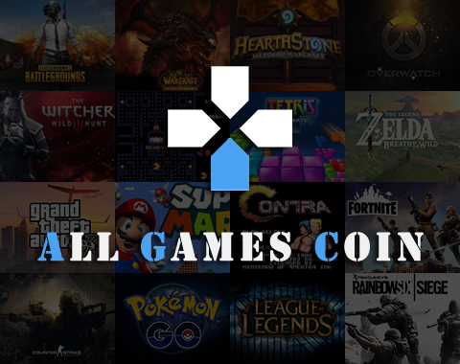

# The Gaming Industry

## The Market Scale

The current state of the global gaming industry in 2018: Newzoo released the latest data. It is estimated that 2.3 billion players worldwide will spend $137.9 billion in games in 2018, which is an increase of 13.3%, or $16.2 billion, from the previous year. Digital games will account for 91% of global revenues, reaching $125.3 billion.

In 2018, mobile game revenue will grow by 25.5% to $70.3 billion. It means that mobile games account for more than half of the game's revenue for the first time. Smartphones contribute 80% of it, or $56.4 billion, and the remaining 20% come from tablets. The console game is the second largest category in 2018, with revenues of $34.6 billion, while PC games will contribute $32.9 billion.

It is estimated that by 2021, game consumer spending will grow to $180.1 billion, with a compound annual growth rate of more than 10.3% between 2017 and 2021. Considering that the global game market revenue in 2012 was 70.6 billion US dollars, this made the 2012-2021 compound annual growth rate reach 11.0%. Maintaining a double-digit growth rate for 10 years is remarkable.

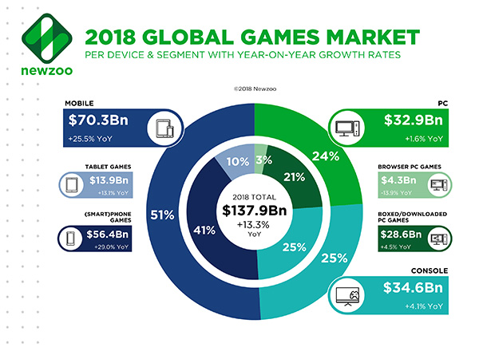

## Game 4.0

The development of the gaming industry has several important stages:

* Game 1.0 - Entity game: People use the props and specific rules to settle the game and the points are settled. The rules and points are settled face to face by the players, and the players reach a consensus. For example: poker, chess, dragons and dungeons.
* Game 2.0 - electronic game: With the development of computer technology, electronic game has been developed. The rules and rewards of the game are preset by the developers. In the meantime, there were some drawbacks such as the use of pirated games and cheating by players.
* Game 3.0 - Online Game: With the development of the network, the game enters the era of network interoperability. Online games use centralized servers which can provide the game asset storage and game rules. In that way, the player's asset security and rule transparency are difficult to guarantee. Each game is an isolated island of information, and the economic system cannot communicate with each other.

Today, Use blockchain technology to change the economic system in the game, rules mechanism, game asset storage. To realize game economy system interoperability, rule trust, asset uniqueness and asset security. The game will enter the game 4.0 era – game with blockchain.

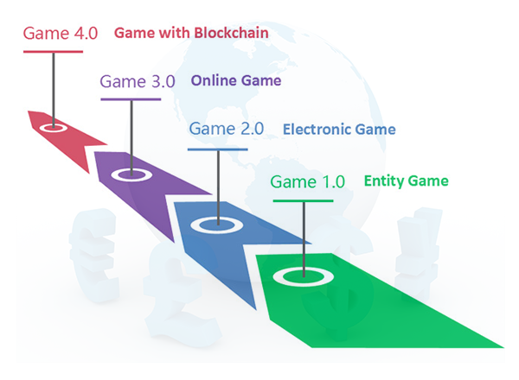

## Preview of the Gaming Industry

Today, the gaming industry is already an important economy. The games that we are familiar with, such as LOL, DOTA2, CSGO, Overwatch, PUBG, Fortnite, WOW, etc., have attracted a large amount of capital inflows, and the events and peripheral products that related to those games have also formed a huge industry.

With the reshaping of the blockchain, the game equipment will become a real asset, the game token will also be truly valuable, and the rules of the game will be transparent and trusted. The blockchain will have a huge impact on the existing gaming system. It will quicken the pace of the gaming industry 4.0 era.

# Application Scenario

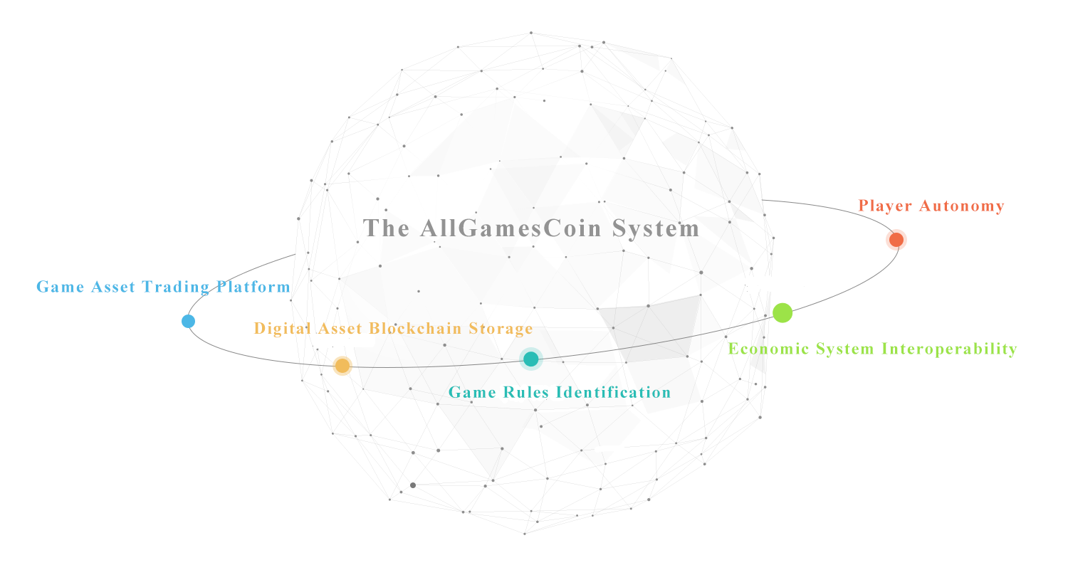

## Game Asset Trading Platform

Interfacing with the digital asset trading platform, such as opskin, igxe, g2g, steam, etc., XAGC becomes a unified trading currency, which eliminates barriers to cross-border transactions and reduces the losses caused by exchange rates.

We will publish a self-developed digital asset trading platform to gradually support all types of mainstream games, open asset trading, and at the same time support access to any game that is willing to use XAGC trading.

## Digital Asset Blockchain Storage

The popular blockchain pets game brings the uniqueness of digital assets and the concept of user-specific which becomes the trait of attracting game users.

Recently, Ubisoft Entertainment announced its expansion into the blockchain and explored proprietary DLC and digital property protection applications based on related technologies. Lidwine Sauer, an Ubisoft executive, pointed out the advantages of the blockchain: it allows users to have unique digital collections, can't copy and is 100% owned by users.

She also cited the example of ‘Starlink: Battle for Atlas’ - the game's spaceship was created by the player's real-world model, and each spacecraft is unique and can be embodied in the game. With blockchain technology, players can have more space to create their own. This has certain application prospects in categories that emphasize collection exchange or emphasis on appearance, such as TCG/CCG games like Hearth Stone and Magic The Gathering, and MOBA games such as LOL and DOTA2.

AllGameCoin System is about to publish a high-performance TrustDB. It provides game developers with easy access to blockchains to store digital assets, providing the most effective support for digital asset uniqueness and storage security.

## Game Rules Identification

The long-standing chess and lottery games all face a common problem, that is, the user's trust in the operator. For example, in the lottery game, the purchase record and the lottery data are provided by the operator, which is lack of openness and transparency. The rules are determined by the centralized service, which is the biggest pain point of the user.

The decentralization and TrustDB of the AllGameCoin System will have a positive effect on solving the trust problem. If the lottery operator deposits the lottery purchase record and the lottery calculation to the blockchain based on the smart contract, the lottery ticket will be more equal and fairer. The user's rights and interests will be most effectively guaranteed. It can also become an important selling point for games such as chess and gambling.

## Economic System Interoperability

Typical game assets have always been in a closed system, lacking commonality. Although virtual assets such as Blizzard Battle Points and Tencent QQ Coins have certain versatility, they are limited to the matrix of their own products, and the trading behavior between players is relatively limited. There are many loopholes such as “seller props traceability” or “buyer black card payment” in the external game asset trading platform. In addition, while most countries' laws protect virtual assets in games, game assets are still heavily dependent on the survival of the product. In the case of special circumstances (such as online games are closed), the user's virtual assets are likely to become worthless.

The emergence of blockchain technology is expected to change the situation of players' virtual assets circulation and transaction restrictions, and also ensure the security of player virtual assets. AllGamesCoin System has prepared two options for the game economy system access:

### Use XAGC

The game directly uses the XAGC as an in-game currency system for exchanging assets with operators and players. The advantage of using XAGC is that the player's game token is a real asset. That means even the server is attacked or the game is closed, the player's currency will never be lost. This type of access is suitable for games that do not release token.

### Release Token

Based on AllGameCoin System’s TrustDB, the game can release its own token as an in-game currency system. AllGameCoin System will provide a market where token and XAGC are freely convertible, and the price of token will be determined by the free market. This type of access is suitable for games that release tokens by themselves.

## Player Autonomy

The gaming industry has always been top-down management. Game contents and rules are determined by the game developer, and the player have to approve the game content by default.

The AllGameCoin System will establish a platform for players to automate. Players can influence and manage game decisions by voting and paying.

### Voting Management

Both game developers and XAGC holders can make changes to the game content. The token share of the XAGC holder will be converted into voting rights. All game developers who follow the AllGameCoin System protocol should implement the revised opinion after voting.

### Payment Management

Game developers want to develop a new game or a new DLC, or players want developers to launch a game sequel, but developers are afraid to start the project because of market risks. At this time, the payment management method can be used, and the player pays the XAGC for the content or the decision. When the XAGC of the payment reaches the expected value, the game developer who follows the AllGameCoin System protocol can start the project.

# TrustDB

After we complete the public blockchain, we will focus on developing the TrustDB for game asset storage, game token distribution, and game rules notarization. Traditional centralized storage is efficient, but it is not credible; decentralized storage can apply trusted storage, but it reduces efficiency. The TrustDB that we create for the game will use a hybrid solution. It separates the data blockchain from the public blockchain and at the same time it is compatible with a centralized database.

## Overall architecture

The overall architecture of a trusted database solution is divided into three layers:

The first layer, the AllGameCoin public blockchain provides a foundation of trust and economic for system operation.

The second layer, the data layer provides decentralized and centralized storage of large amounts of data, and stores trusted flag in the public blockchain.

The third layer is about the application layer. On the basis of the public and data layers, it will create high-use, scalable applications, such as: store game asset, release game token, identify game rules and so on.

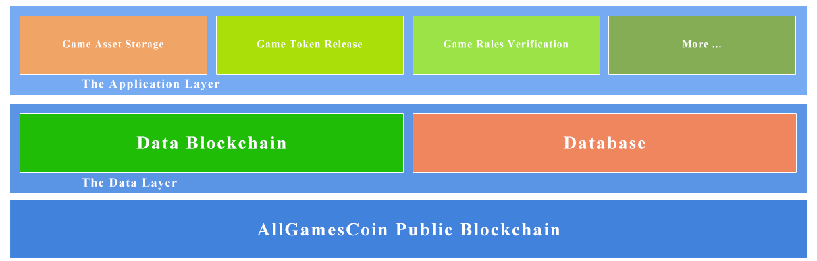

## The AllGameCoin Public Blockchain

The AllGameCoin public blockchain only stores XAGC transactions and data layer trusted flag. It can effectively avoid the public blockchian’s data becoming huge and difficult for ordinary users to use, and can also avoid the fast access of the data layer by the public blockchain’s confirmation time.

## The Data Layer

### Data Blockchain

A separate, high-performance data blockchain dedicated to the storage of data. The data blockchain will not have its own coins and the incentive system will use XAGC as a reward. The data blockchain will use the super nodes. We will openly campaign 100 super nodes globally as nodes of the data blockchain with a target of one million TPS. The data of the data blockchain that has been authenticated by the super node will be packaged once every 2 minutes and stored in the AllGameCoin public chain for secondary authentication.

### Database

Developers will be able to use their own database, and XAGC will store the flag of the data changes. It will support relational databases such as MySQL, Oracle, MS SQL Server.

## Application Layer

The application layer abstracts the blockchain application scenarios in various typical games. It provides basic capabilities and implementation frameworks. So developers can easily implement business logic in the blockchain using the application layer.

### Game Asset Storage

Developers can map the assets that off the blockchain to the blockchain. After the assets are chained, the transfer, splitting, and destruction of the assets require strict control of the account with public and private key system. All operations will have signature verification, and both parties will stay. The traces are not erased. The operation of the game assets will consume a certain amount of XAGC, and the amount of XAGC consumed is determined by the free market.

### Game Token Release

Developers can quickly release game tokens with blockchain technology through this application, and token transactions consume a certain amount of XAGC. Developers can easily implement token release, token transactions, and token inquiries through it. It can exchange game tokens and XAGC through the free market exchanged.

### Game Rules Verification

The blockchain plays an indelible and publicized ability in the verification of rules. Game rule verification allows developers to store rules that require assurance in the blockchain. The two-level verification that is unique to the AllGameCoin System makes the assurance more credible.

# Blockchain

## Overview

|  |  |
| --- | --- |
| Name | AllGamesCoin |
| Symbol | XAGC |
| Coin Type | POW/MN |
| Algorithm | X16R |
| Block Time | 2 Mins |
| Max Coin Supply | 21000000.00000000 |
| New Coin Supply Time | 17395.00 Days |
| Initial Reward | 20.00 |
| Decrement Cycle | 1 week |
| Weekly Decrement | 0.484% |
| POW Reward Percentage | 51% |
| MN Reward Percentage | 49% |
| RPC Port | 7207 |
| MN Port | 7208 |
| Pre-mining | 0.83% |

## Algorithm

As a technical supporter of the game, we hope that all players can join the mining with their own graphics cards. We used the algorithm X16R to against ASIC Miner. ASIC miner tend to concentrate mining rights, which is not what we want, so we will always keep our algorithms mineable only with graphics cards.

The X16R hashing algorithm consists of 16 hashing algorithms operating in chain fashion with the ordering dependent on the last 8 bytes (16 nibbles) of the hash of the previous block. The algorithms are as follows:

|  |  |
| --- | --- |
| Order | Algo |
| 0 | blake |
| 1 | bmw |
| 2 | groestl |
| 3 | jh |
| 4 | keccak |
| 5 | skein |
| 6 | luffa |
| 7 | cubehash |
| 8 | shavite |
| 9 | simd |
| 10 | echo |
| 11 | hamsi |
| 12 | fugue |
| 13 | shabal |
| 14 | whirlpool |
| 15 | sha512 |

code：<https://github.com/allgamescoindev/x16r_hash>

## Reward

Unlike BTC's rewards, which are halved every four years, AllGameCoin System has designed a smoother reward reduction. We have reduced the amount of rewards by 0.488% per week, which has steadily increase the value of XAGC.

## Supply

The total supply of coins is 21,000,000 and the total supply time is 17395 days (48 years).

## Reward Rate

POW has a 51% share and MN has a 49% share. It is the most efficient way to balance the security of the blockchain and the energy consumption of mining.

# Road Map

## 2018Q3

* AllGamesCoin Public Blockchain release
* Publish White Paper
* Windows/Linux/OSX Wallet release
* The AllGamesCoin Website goes live
* The AllGamesCoin Block Explorer goes live
* The AllGamesCoin Pool goes live
* The XAGC Auto Miner release
* AllGamesCoin listing on exchanges
* AllGamesCoin listing on masternodes.online

## 2018Q4

* Game Asset Trading Platform Test release
* AllGamesCoin listing on more exchanges
* Sponsoring E-sports competitions

## 2019Q1-Q2

* Game Asset Trading Platform release
* AllGamesCoin startups Data Blockchain Testnet
* AllGamesCoin Linux Data Wallet Testnet release
* AllGamesCoin startups Application Testnet

## 2019Q3

* AllGamesCoin startups Data Blockchain
* AllGamesCoin Linux Data Wallet release
* AllGamesCoin startups Application

## 2019Q4

* AllGamesCoin Developer Tools release
* Player Autonomous Management Platform goes live

# Future

* Establish our own trading platform and use XAGC for trading. When the business model is mature, it will enter other trading platforms, such as opskin, igxe, g2g, steam market, etc., to become a unified trading currency. This will replace the currency of each country and reduce the transaction losses caused by the exchange rate.
* Use the trading platform to earn bonuses for major e-sports events. Players and teams are ranked in the world by XAGC, which makes the world rankings of teams and players fair, objective and transparent.
* Through TrustDB, the following goals are achieved: First, the game manufacturer releases the token on the platform or directly uses XAGC as the common currency of the online game to realize an economical inter-connected economy within each game. Second, the in-game assets are on the chain, creating a unique asset system, so that each piece of equipment is unique. Third, the game rules identification, some games can be through the XAGC system-specific TrustDB system for two-level certification, making it become authentic.
* In-depth cooper ation with major game companies, players can invest in their favorite games through the XAGC held in their hands and then propose changes, or set up a game project, so that players really join the game industry, become the number one player.